CNSL Lab Assignment 12
Neeti Kurulkar
To study SSL protocol by capturing the packets using Wireshark tool while visiting any SSLsecured website (banking, e-commerce, etc)
- An SSL Protected Website
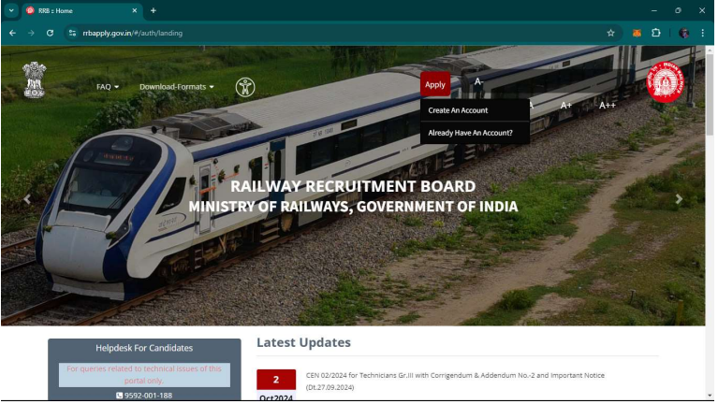

- Filtering SSL and TCP Stream 6
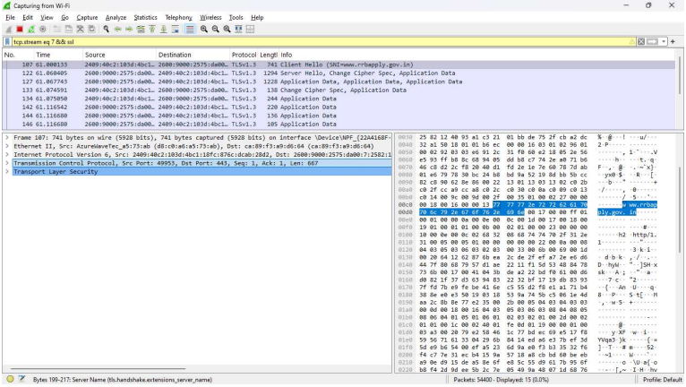

- TLS Handshake Protocol for Client Hello
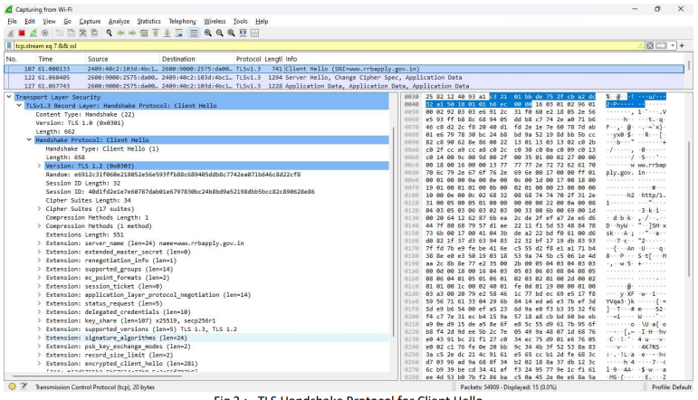

- TLS Handshake Protocol for Server Hello
